
In October of 2002, my wife, three sons, and I took a 2-week trip to China so that we could adopt our daughter who was 11 months old. We had no idea how things would go because none of us spoke Mandarin.

Our flight to Beijing was a very long 11 hours. We left 35 minutes late at 1:05 pm Vancouver time and arrived at 3:00 pm Beijing time. Our guides and bus took us and 13 other adopting families from all over Canada to the Sino-Swiss Hotel. We had to stay there overnight before flying to Kunming in Yunnan province.
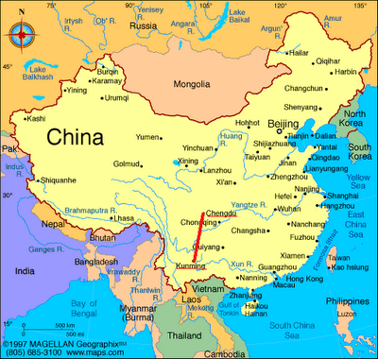
Half of the families flew to the Fujian province for their adoptions. Our 9 a.m. flight to Kunming was a relatively short 3 hours. After landing, we took a shuttle to the Green Lake Hotel. Kunming had a population of 4.5 million at the time and Yunnan had a population of 40 million. At the time, very few people spoke English because it was not a major tourist destination.

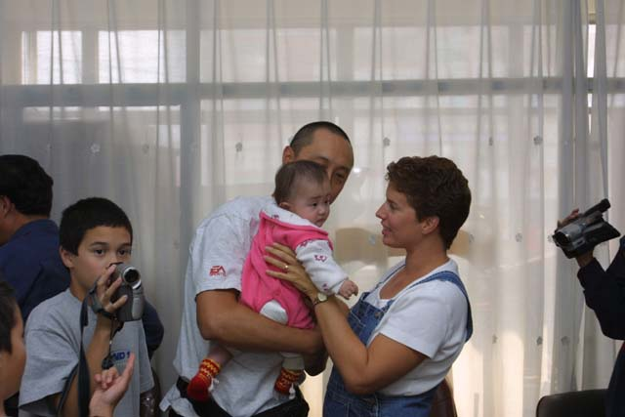
Although we were scheduled time to have lunch, we only had time to grab a can of Coke. They immediately took us to the Civic Affairs building for paperwork. It was a little concerning there because there were soldiers with assault rifles. They were there to guard the donation money. It took quite some time, but we were expecting to go back to the hotel afterwards; we didn’t realize that we were picking up the babies at the same time because we were initially told it would be the next day! The funny thing that happened is that we did not know how our daughter’s name was pronounced and neither did another family, so they accidentally picked up our daughter – this was resolved rather quickly though.

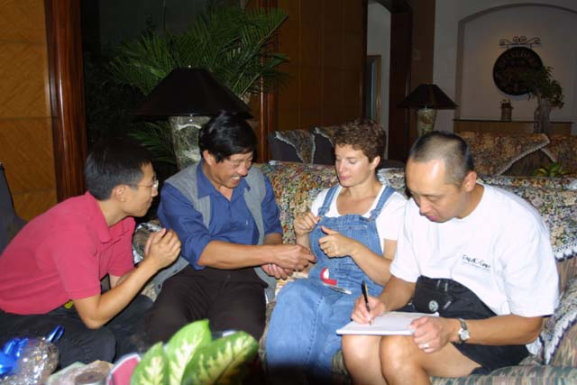
All the families and their new babies returned to the hotel at about 6 p.m. We had dinner and our family and 2 other families had a surprise visit from the orphanage director and nannies that our daughters came from. Apparently, they brought our daughters from the orphanage that was over 6 hours away over dirt roads; they wanted to give us some information about our daughters and some gifts for them for when they got older. It was great that we got some extra information about them because it rarely happens!

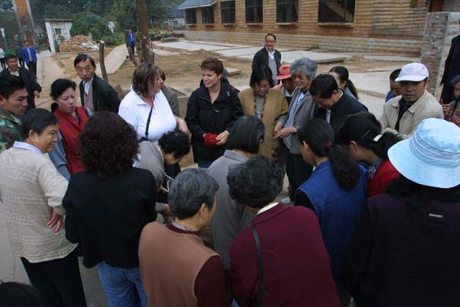
So for the next week and a half, we spent time getting to know our daughter and being tourists in Kunming and Beijing! It was kind of weird because my sons were very tall at the time and we had a large family since China had a one-child policy, so we got a lot of stares walking around! One of our favourite spots ended up being walking around Green Lake Park where people gathered to practice Tai Chi, play chess, play Mah Jong, and many other activities. Some unexpected things we found in Kunming were a Wal-Mart and KFC; the Wal-Mart had a distinctive Chinese twist. Although we did go to Wal-Mart a few times, we tried to keep our trip as authentically Chinese as possible.

There are 2 basic ways to insert pictures into your document: adjust the margins and freely place the image; or have the words adjust around the image.

Freely place the image:
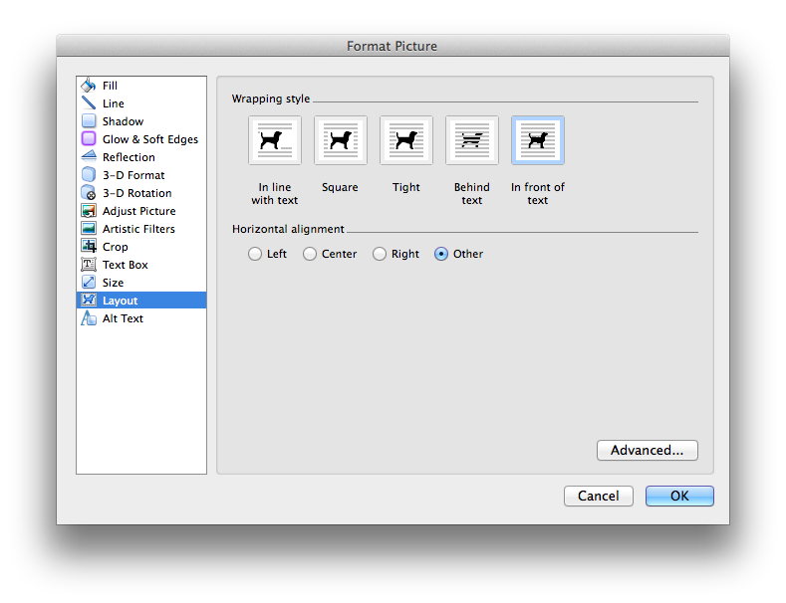
Use the “Other” horizontal alignment and “In front of text” Wrapping style.

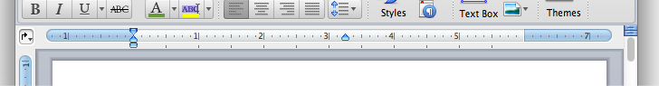

Next, you will need to set your margins to the left or right to make room for the image, as seen above. Then drag and size the image for the best look.

Make words wrap around image:
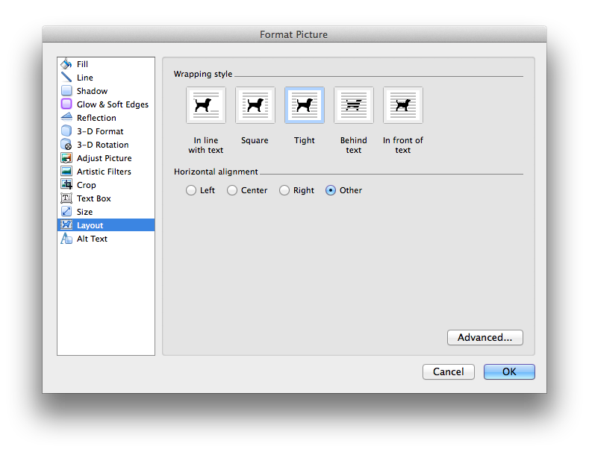
Use the “Other” horizontal alignment and “Tight” Wrapping style. Leave the margins to the regular full width. Then simply drag and size the image for the best look. Generally, you won’t want the image in between the text, rather you will want it to the left or right.

To ensure that you get full marks:
- Use your own words and thoughts rather than just plain facts.
- Use at least 6 relevant images.
- Use different placements of images and text.
- Use consistent and relevant font changes: type, size, style, colour, and effects.
- Write at least 300 words.
- Minimize spelling and grammar mistakes.
- Include links document for images.

There is no bad exemplar. A poor assignment is simply missing many of the above objectives.

